**DevOps Work Updates**

**1 Creating CI/CD for react front-end in Azure DevOps**

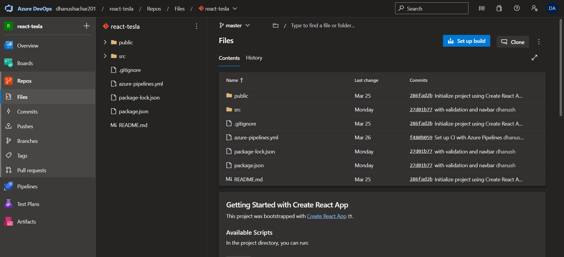

Yaml file CI

# Define the pipeline name and trigger

name: ReactJS-CI

trigger:

- main

# Define the pool of agents to use

pool:

  vmImage: 'ubuntu-latest'

# Define the stages of the pipeline

stages:

- stage: Build

  jobs:

  - job: Build

    steps:

    - task: NodeTool@0

      inputs:

        versionSpec: '14.x'

      displayName: 'Install Node.js'

    - script: |

        npm install

        npm run build

      displayName: 'Install dependencies and build the app'

    - task: ArchiveFiles@2

      inputs:

        rootFolderOrFile: '$(System.DefaultWorkingDirectory)/build'

        includeRootFolder: false

        archiveFile: '$(Build.ArtifactStagingDirectory)/$(Build.BuildId).zip'

      displayName: 'Archive build artifacts'

    - publish: $(Build.ArtifactStagingDirectory)/$(Build.BuildId).zip

      artifact: build

      displayName: 'Publish build artifacts'

In the yaml file as mentioned it creates build artifacts and publishes it in drop folder for release pipeline

Release Pipeline

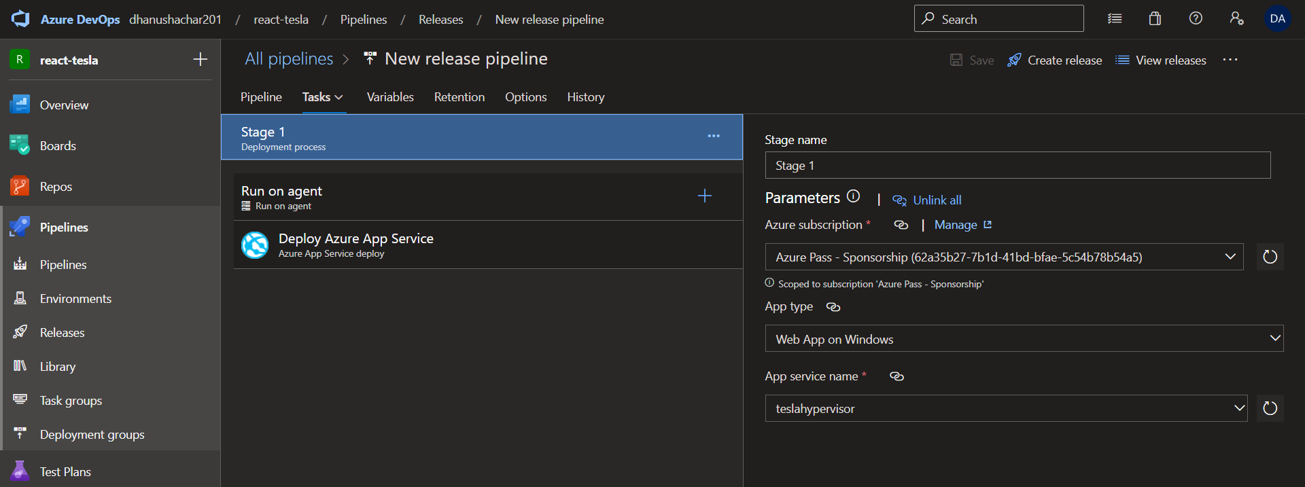

The release of zip file will be done in App service as shown below

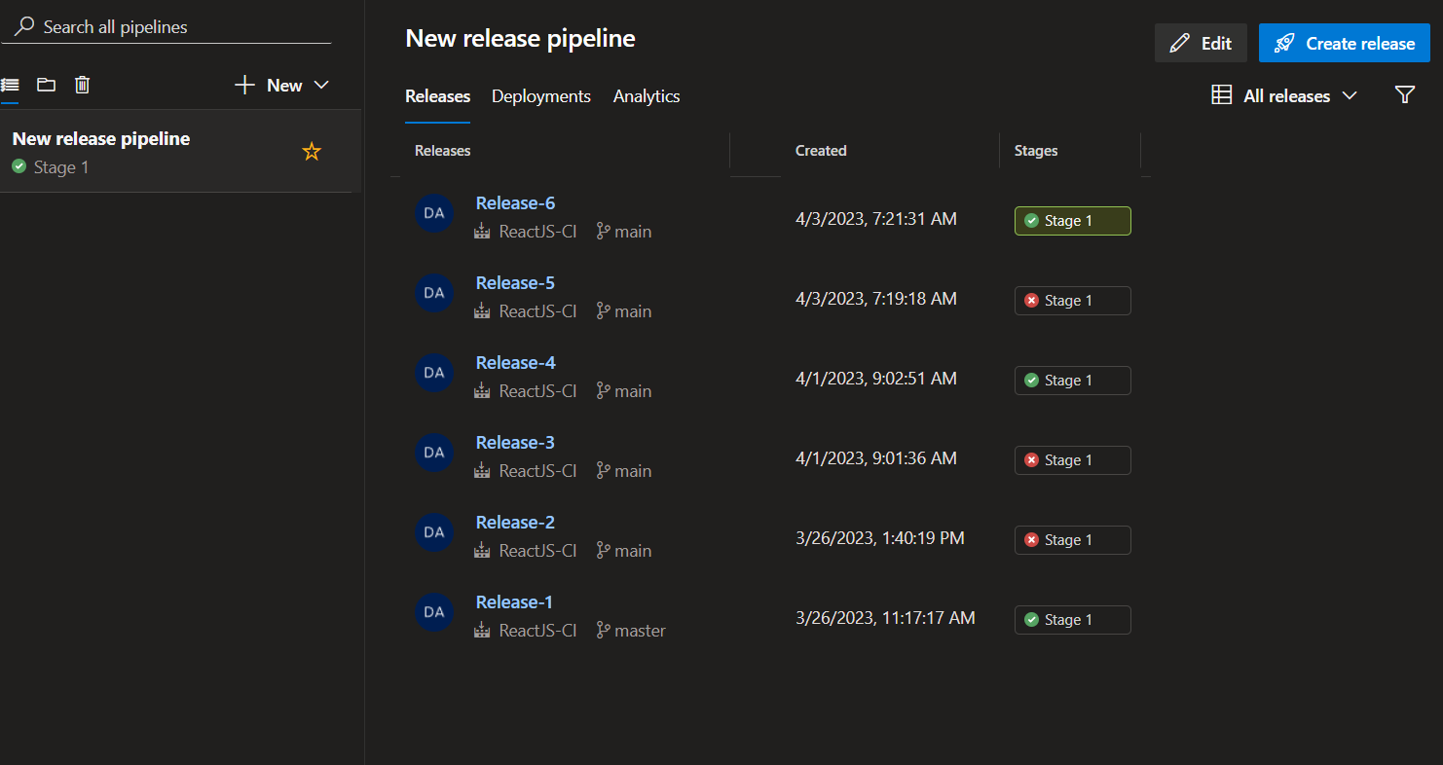

In App service

URL of AppService

<https://teslahypervisor.azurewebsites.net/>

as my credits as been expired this link can not be served but I am requesting for another 50 dollars sub from IT team so that I can present it on Monday

**I am trying to do Jenkins CI for SAP Hybris and I will also try to do the same react project using ACR and kubernities cluster later on**